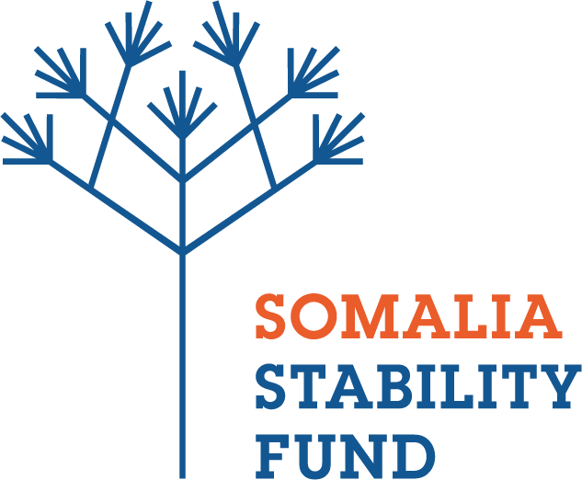
REQUEST FOR PROPOSALS (RFP)

Prequalification of consultancy services to carry out analytical work in Somalia

SSFMR-020-C01

Background
The Somalia Stability Fund is seeking to prequalify research firms to provide analysis for a period of approximately one year to inform SSF decision-making as well as inform the wider donor community. SSF will invite prequalified firms to submit proposals in response to the following types of analysis required by SSF on a need basis:
- Political economy analysis to better understand key incentive structures, elite pacts and resource flows in different geographical contexts in Somalia; and how these might impact on reform processes and development programming.
- Gendered district context analysis for specific locations to understand the power dynamics between different social groups and genders and the economic, social, political, conflict and security situation in the district.
- Analytical work on topics related to conflict and stability, for example potential impact of elections/change in leadership at the FMS level/actions of regional actors; stabilisation trajectory and other areas that the Fund identifies as relevant.

Analysis completed under various awarded contracts to selected prequalified firms will be used by SSF and their implementing partners to guide programme decision making. It will also be shared more broadly in the donor community and with government to drive learning and inform the wider stabilisation agenda in Somalia, with appropriate caveats in terms of the sensitivity of the information.
SSF invites proposals (“Bids”) from eligible and qualified entities (“Bidders”) to undertake the works referenced above. Bidding will be competitive and is open to all qualified organizations. General details relating to the work are highlighted below:
Interested bidders are requested to submit their proposal comprising one electronic submission of Technical Proposal and one electronic submission of Financial Proposal separately.
Interested Bidders are advised to click on this link https://bit.ly/2D0CXyu to access the full RFP package.

Technical Proposal
Email completed Technical bids to procure@stabilityfund.so clearly marked: Technical proposal- Analytical Work in Somalia (SSFMR-020-C01) in the title of your email.

Financial Proposal
Email completed Financial bids to financialproposals@stabilityfund.so clearly marked: Analytical Work in Somalia (SSFMR-020-C01) in the title of your email.

For clarification questions, please email us at procure@stabilityfund.so no later than Wednesday, 20 February 2019 at 1400hrs (EAT). Responses to clarification questions shall be uploaded and accessed through the OneDrive link https://bit.ly/2D0CXyu containing the RFP documents on Thursday, 28 February 2019 at 1700hrs (EAT)

No exceptions will be made for late entries. Please note, only short-listed applicants will be contacted.

DEADLINE FOR SUBMISSION: Monday, 4 March 2019 at 2330hrs (EAT)

